Question 5

* Create a simple LAN setup with two Linux machines connected via a switch.
* Ping from one machine to the other. If it fails, use ifconfig to ensure the IP addresses are configured correctly.
* Use traceroute to identify where the packets are being dropped if the ping fails.

Approach

**Create a simple LAN setup with two Linux machines connected via a switch.**

Here we don’t have any physical switch so we are using gns3 and VM machines. We will first connect VM’s to GNS3 and make a LAN connection in GNS3 and test it in virtual machines

First we need to add virtual machines. Before that make sure you installed two linux machine in virtual box

Under

edit > preferences > VirtualBox VMs > New > [Your machine name] > ok

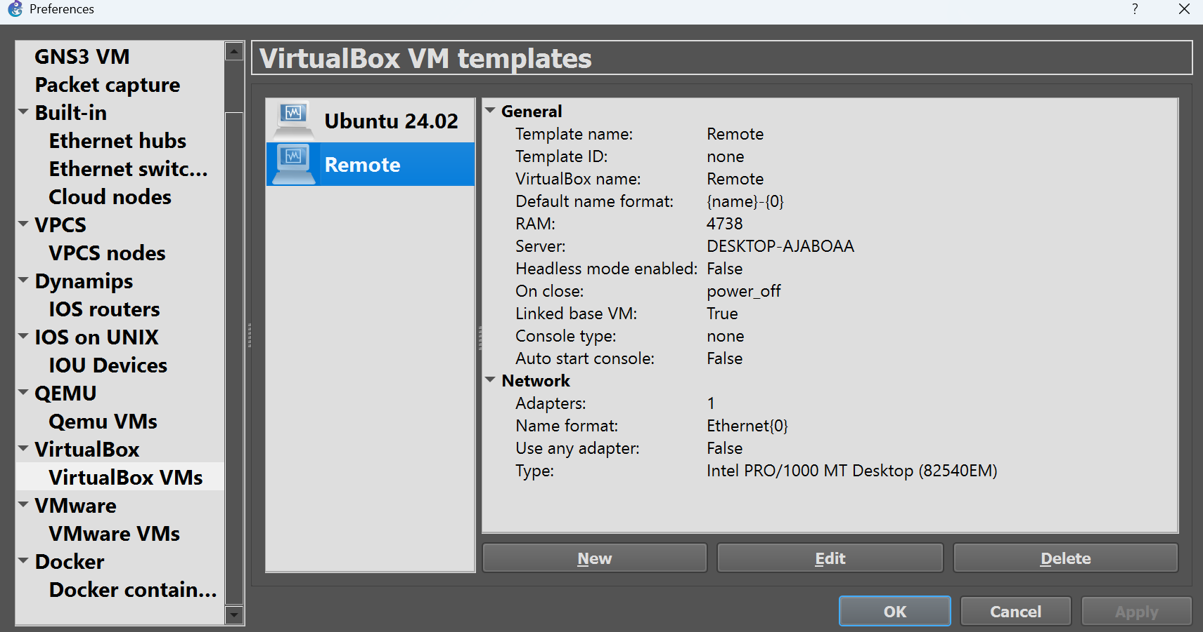

Once all your machine is integrated you restart the GNS3. Now you go to virtual box and configure the network by enabling the adapter 2 and keep it in nat or internal network

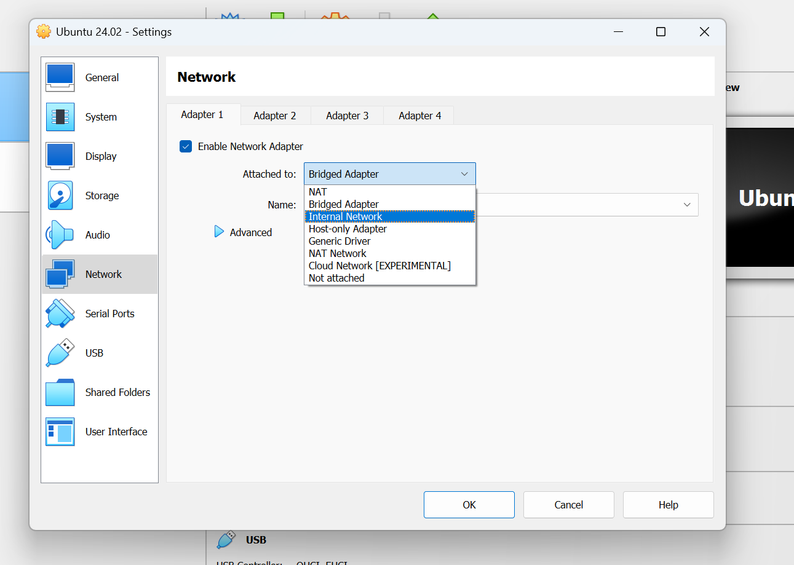

Now create the below given connection in GNS3 software and run it

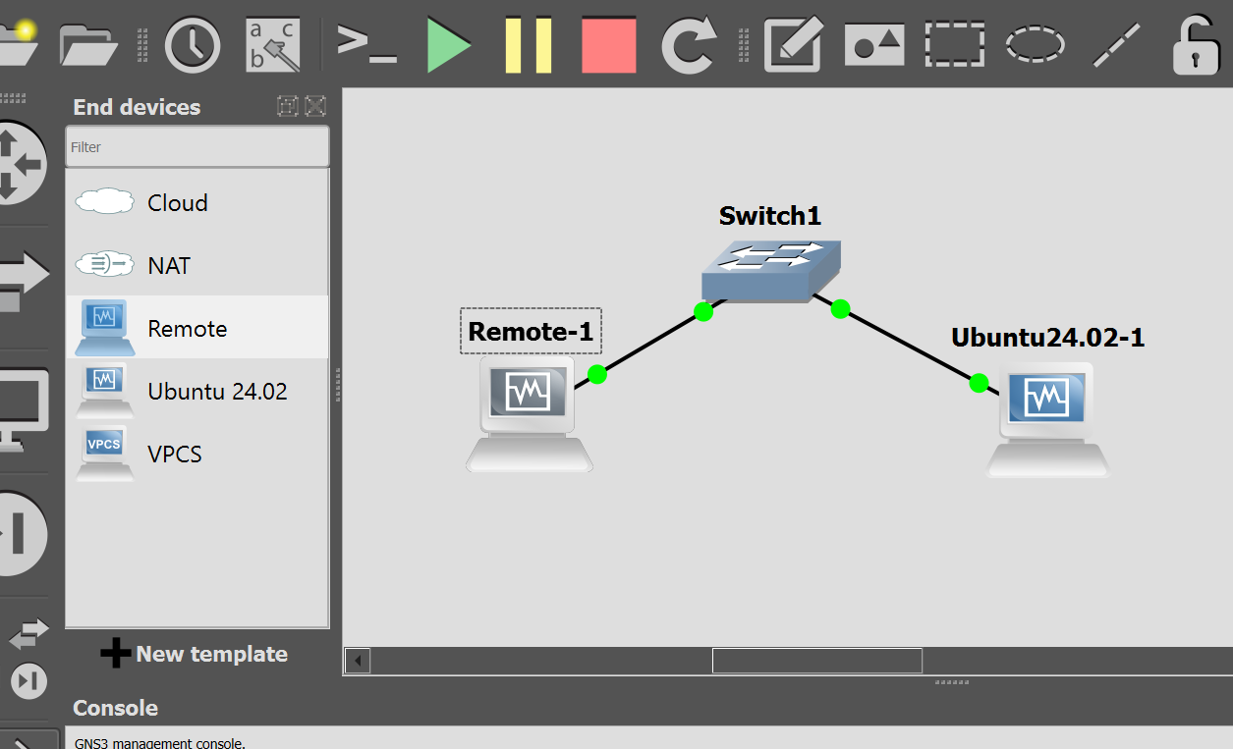

It will automatically start the machines.

Now check the ip of each machine and try to ping it

You will be able to ping any machine from any machine

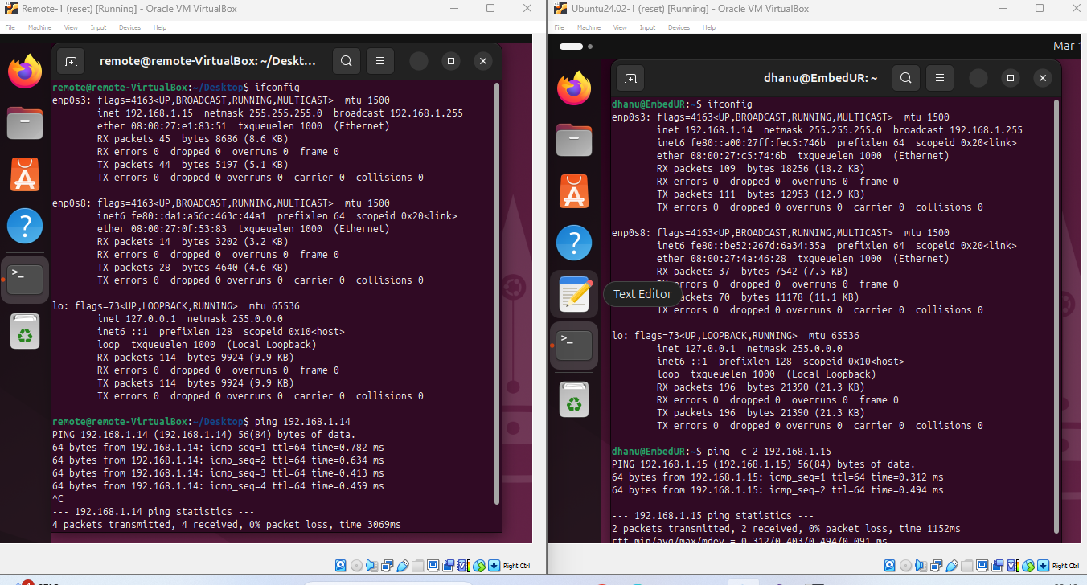

**Ping from one machine to the other. If it fails, use ifconfig to ensure the IP addresses are configured correctly.**

Here if we ping from one pc to another it works perfectly. But there are some case where ping fails.

* **The very first thing which has to be noted is the cable connecting the switch and PC**

Try to check the link between system and switch with

ip link show

If no link with switch is shown then try to check whether you connected the switch with copper straight through cable. If not change it. Any issue in ethernet cable or damaged ethernet cable may cause a problem in connectivity.

* **Both machines are in different subnets (192.168.1.0/24 and 192.168.2.0/24)**.

A switch alone does not perform routing, so packets cannot travel between subnets. To overcome this issue add a router to facilitate communication or change the ip address by the below command. Make sure both has same subnet

sudo ifconfig [Network] [IP_addr] netmask [subnet addr] up

Ex: sudo ifconig enp0s3 192.168.1.10 netmask 255.255.255.0 up

Once you done with it check the Ip using ifconfig command. You can also use router to overcome the issue.

* **If any one of the machine does not have default gateway, This problem may occur**.

To over come this add a default gateway route to your ip route. First check ip route. You will not have a route to system two. Add one with the below code

sudo ip route add default via [ipp_addr]

Once done restart your network manager. If you face any issues in adding route restart your Network Manager and try again.

* **Next occurring issue is that firewall may block our ICMP packet.**

To overcome this issue you have to disable the uncomplicated firewall in your linux machine. Use below command for it

sudo ufw disable

* **Sometime issue occur with ARP table**.

The ARP table cache may contain different MAC address of your ip. Clear the arp cache and try again.

sudo ip -s -s neigh flush all

* **Sometim issue is with duplicate IP address.**

It may occur network conflit. The device don’t know where to send the packet. To overcome this use unique ip address for each virtual machine

* **You would have use different or incorrect subnet mask**

Here I attach the class of IP and it’s subnetmask kindly refer and change it accordingly

|  |  |  |  |  |  |  |
| --- | --- | --- | --- | --- | --- | --- |
| CLASS | START | END | SUBNET | CIDR/Notation | No.of Devices | Usage |
| A | 1.0.0.0 | 126.255.255.255 | 255.0.0.0 | /8 | 16 million + | Large Network |
| B | 128.0.0.0 | 191.255.255.255 | 255.255.0.0 | /16 | 65,536 | Medium Network |
| C | 192.0.0.0 | 223.255.255.255 | 255.255.255.0 | /24 | 256 | Small Network |
| D | 224.0.0.0 | 239.255.255.255 | N/A | N/A | N/A | Reserved for multicast |
| E | 240.0.0.0 | 255.255.255.255 | N/A | N/A | N/A | Reserved for experimental/ future use |

Here 127.x.x.x never leave the device it is reserved for loopback address